November 29, 2023  9:00AM – 4:00PM EST  2023 Home Health Reimbursement Workshop | 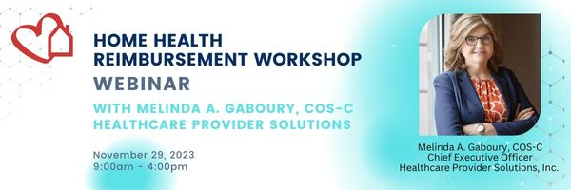

This workshop will take agencies through the significant updates to the PDGM reimbursement model and move through all the aspects of home health reimbursement.
PDGM has brought many changes to home health and 2023 will continue to keep agencies on their toes while adapting fully to the model, including dealing with the NOA. There will be a discussion of Pre-Bill claim reviews and the significance of conducting them. The impact of OASIS & Coding and medical review programs has the potential to more directly impact reimbursement than some of the other aspects of PDGM and this workshop will get you up to date on all that. 2023 also brings the implementation of Value-Based Purchasing (VBP) and OASIS-E. This workshop will hit the highlights of both as they impact reimbursement. In addition to Traditional Medicare, the Medicare Advantage plans have become a major part of home health reimbursement, and this workshop will take you through some of the detail aspects of getting what you need in order to get paid. Medical Review has emerged as one of the greatest concerns for home health. This workshop will take you through the contractor asks and dig into the reasons behind review. PEPPER reports are a large part of the data used to target agencies and this workshop will give you an up to date review of how to analyze your current PEPPER. Whether you are a biller, collector or Administrator, this workshop is just what is needed to get you up to date on all things Home Health Reimbursement.
- Program Goals: Day to Day Revenue Cycle Under PDGM
- Evaluate the PDGM Structure
- Detail the significant impact of Intake on Revenue Cycle
- LUPA, PEP Calculations
- Details of Billing RAP & Final Claim
- OASIS & Coding Impact on Reimbursement
- Brief overview of VBP & OASIS-E
- Detail Credentialing with Managed Care & Issues surrounding getting paid
- Medical Review – all contractors
- PEPPER Reports – monitoring and evaluating


Presenter: Melinda A. Gaboury, COS-C
CEO - Healthcare Provider Solutions
Melinda A. Gaboury is co-founder and Chief Executive Officer of Healthcare Provider Solutions, Inc. (HPS). Melinda Gaboury and Mark Cannon founded the company in April 2001 to provide financial, reimbursement, billing, operational and clinical consulting to the home care and hospice industries.
Melinda A. Gaboury, with more than 30 years in home care, has over 22 years of executive speaking and educating experience, including extensive day to day interaction with home care and hospice professionals. She routinely conducts Home Care and Hospice Reimbursement Workshops and speaks at state association meetings throughout the country. Melinda has profound experience in Medicare PDGM training, billing, collections, case-mix calculations, chart reviews and due diligence. UPIC, RA, ADR & TPE appeals with all Medicare MACs have become the forefront of Melinda’s current impact on the industry. She is currently serving as the Chair of the NAHC/HHFMA Advisory Board and Work Group and is currently serving on the Board of Directors for both the Home Care Association of Florida & Tennessee Association for Home Care. Melinda is also the author of the Home Health OASIS Guide to OASIS-E and Home Health Billing Answers, 2023.

Confirmation: Prior to the webinar, you will receive a Zoom confirmation email which will include a join link to access the webinar, a dial-in number and an access code to listen in via telephone. You will also be sent any pertinent handouts if available.

Recording: This session will not be recorded.

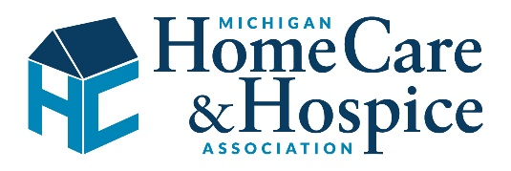

2023 Home Health Reimbursement Workshop
November 29, 2023 | 9:00AM – 4:00PM EST

Registration Fee: The registration fee covers one individual and one continuing education (CE) certificate (if applicable). Multiple site participation from individuals within your agency will require separate registration. For example: if your agency has paid for 1 participating registration but 3 people from your agency would like to attend (and receive CE credit), your agency will need to pay a separate registration fee for all 3 participants. In addition, if your agency has sent in 1 registration but 3 people from your agency register through the Zoom link, your agency will be invoiced the registration fee for the additional 2 registrations. The handouts will be emailed to you to the email address you provide.

Cancellation and Substitution Policy: Fees will be refunded, or invoices will be adjusted, only if written notice of cancellation is received by MHHA one week prior to the event. In the event of cancellation, MHHA will retain, or charge, 50% of the initial registration fee, per registrant, to cover administrative overhead. Once written cancellation is received, an MHHA staff member will review for approval. If your cancellation is approved, we will email back a signed and dated copy of the cancellation that your agency should retain on file in case of questions. Substitutions may be made up to the day of the event. Please contact cindyt@mhha.org if you have any questions.

Continuing Education: This webinar is eligible for 6 Nurse Contact Hours.
The Association for Home and Hospice Care of North Carolina is approved as a provider of nursing continuing professional development by the North Carolina Nurses Association, an accredited approver by the American Nurses Credentialing Center’s Commission on Accreditation.

Please Make Your Selection Below:
Association Members | $190.00
Potential Members | $380.00

Amount Enclosed
Attendee Name
Agency Name
Agency Address
City State Zip | Phone
Attendee Email | Alternate Email
If paying by check, please make payable to MHHA.
Credit Card Number | Exp. Date
Name (as it appears on card)
Address of cardholder
Email Address for CC receipt
Signature (required)
Registration must be received in writing and will not be accepted without payment. Three easy ways to register:
1. | Online Registration - please visit the calendar of events www.mhha.org.
2. | Mail registration form with total registration fees (check or credit card) to:  (MHHA, 2140 University Park Drive, Suite 220, Okemos, MI 48864
3. | Fax form with total registration fees (credit card) and signature to (Fax Number)
Contact 517/349-8089 or cindyt@mhha.org with questions.

